What is Segmentation || Non-Contiguous Memory Allocation

Paging has one problem, as it divides processes into pages of same ssize. Now if you have page size of2 kb, an if we have a function fun of 4 kb . Now the os will divide it in 2 2 kb each.

Lets say page1, page2. The instruction are stored at to different locations. So the page switches to page 2. They may have located at spaces. This may cause overhead.

Segmentation’

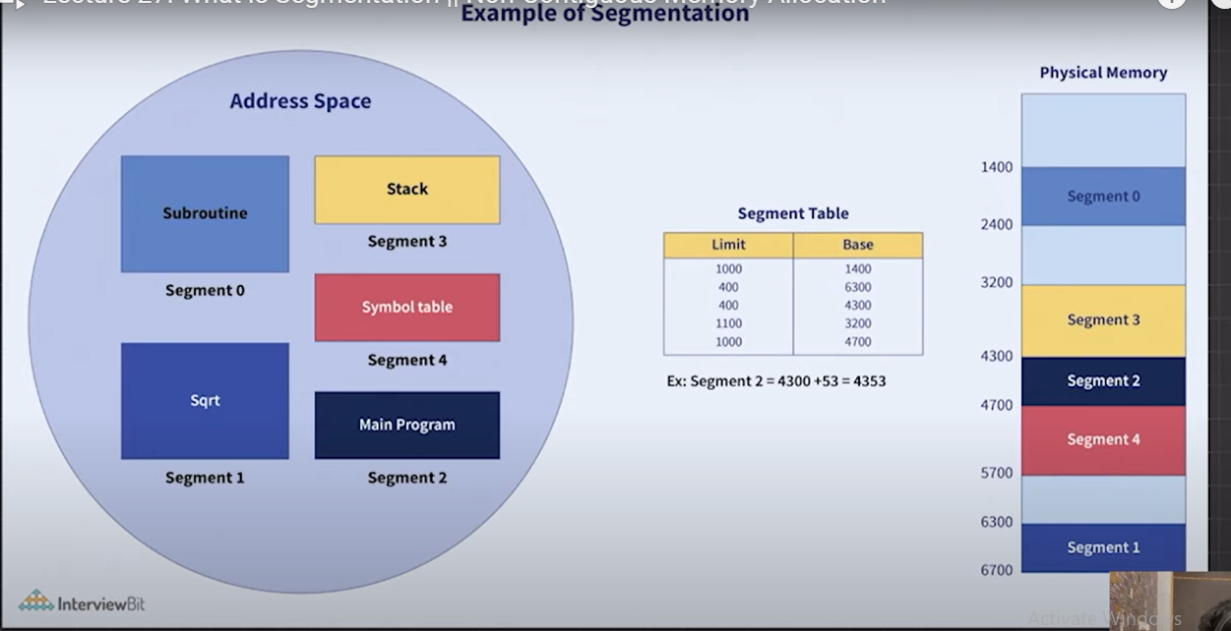

Refer pdf notes

Modern System architecture provides both segmentation and paging implemented in some hybrid

approach.